LAB PROGRAM 8

Write a program that demonstrates handling of exceptions in inheritance tree. Create a base class called “Father” and derived class called “Son” which extends the base class. In Father class,implement a constructor which takes the age and throws the exception Wrong Age( ) when the input age=father’s age.

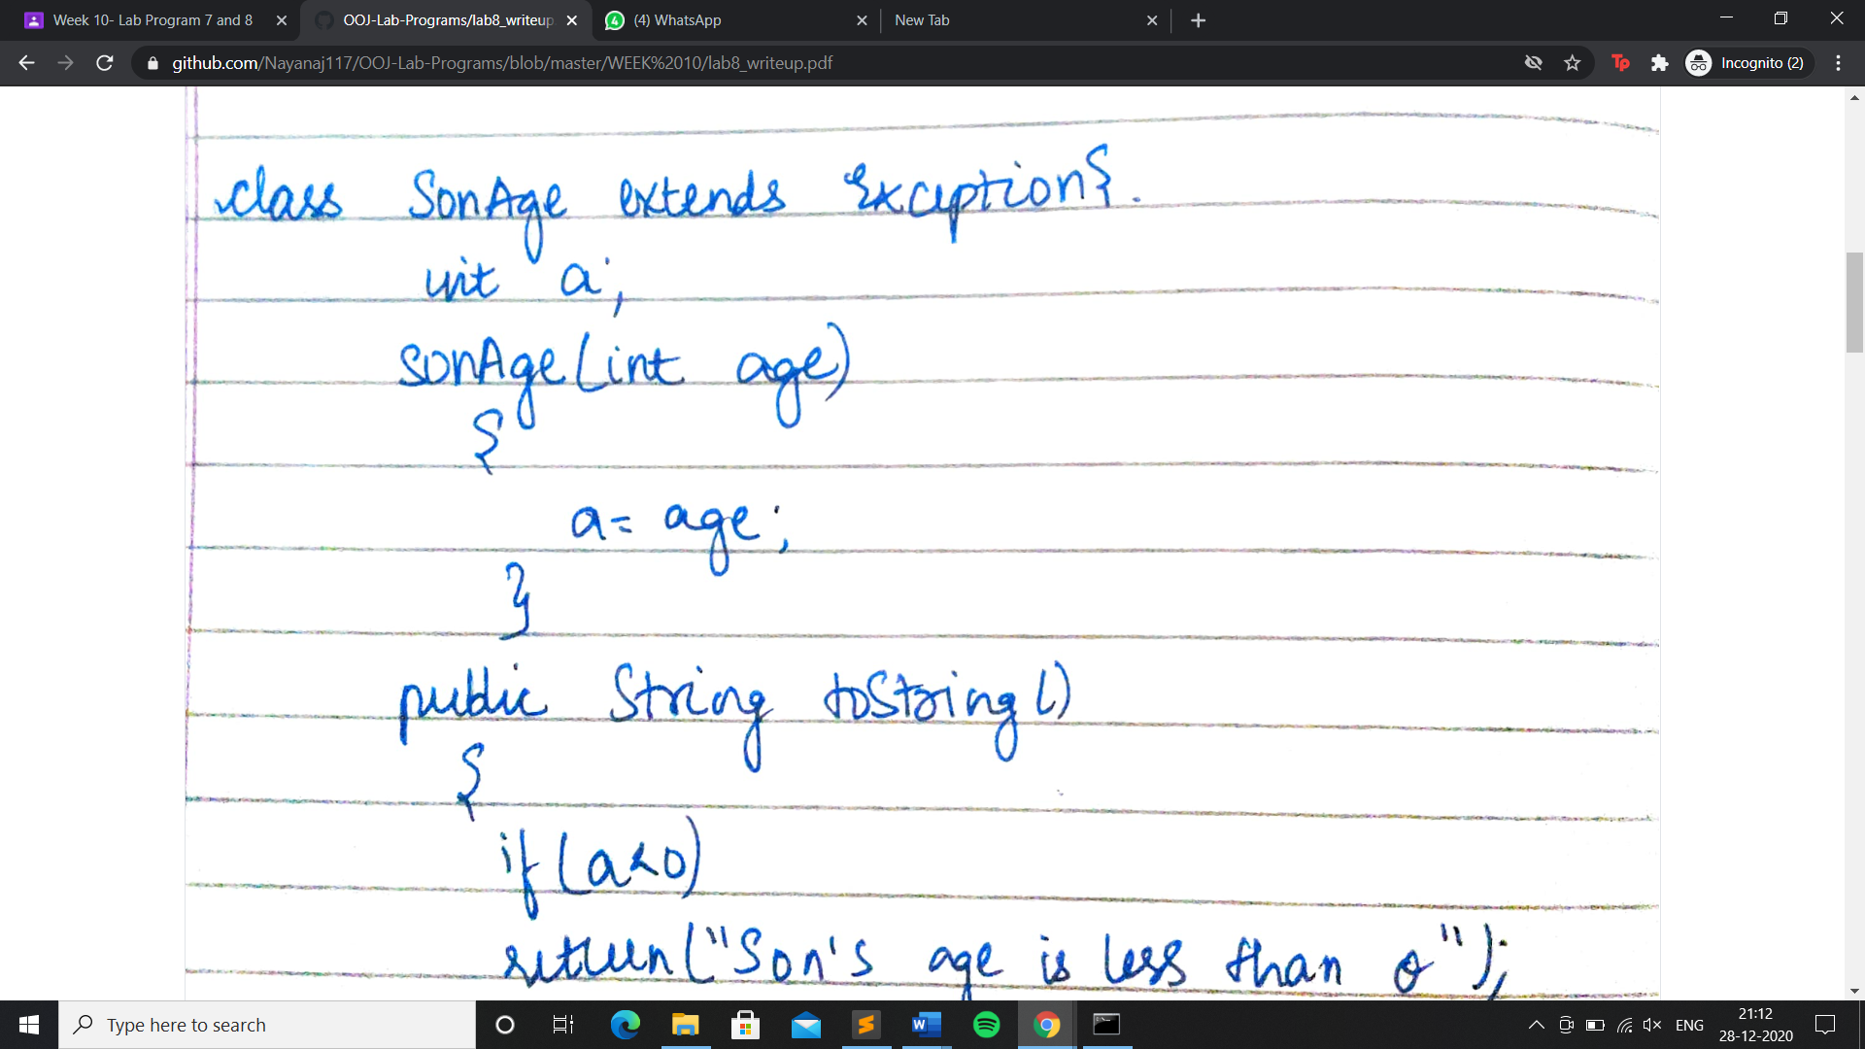

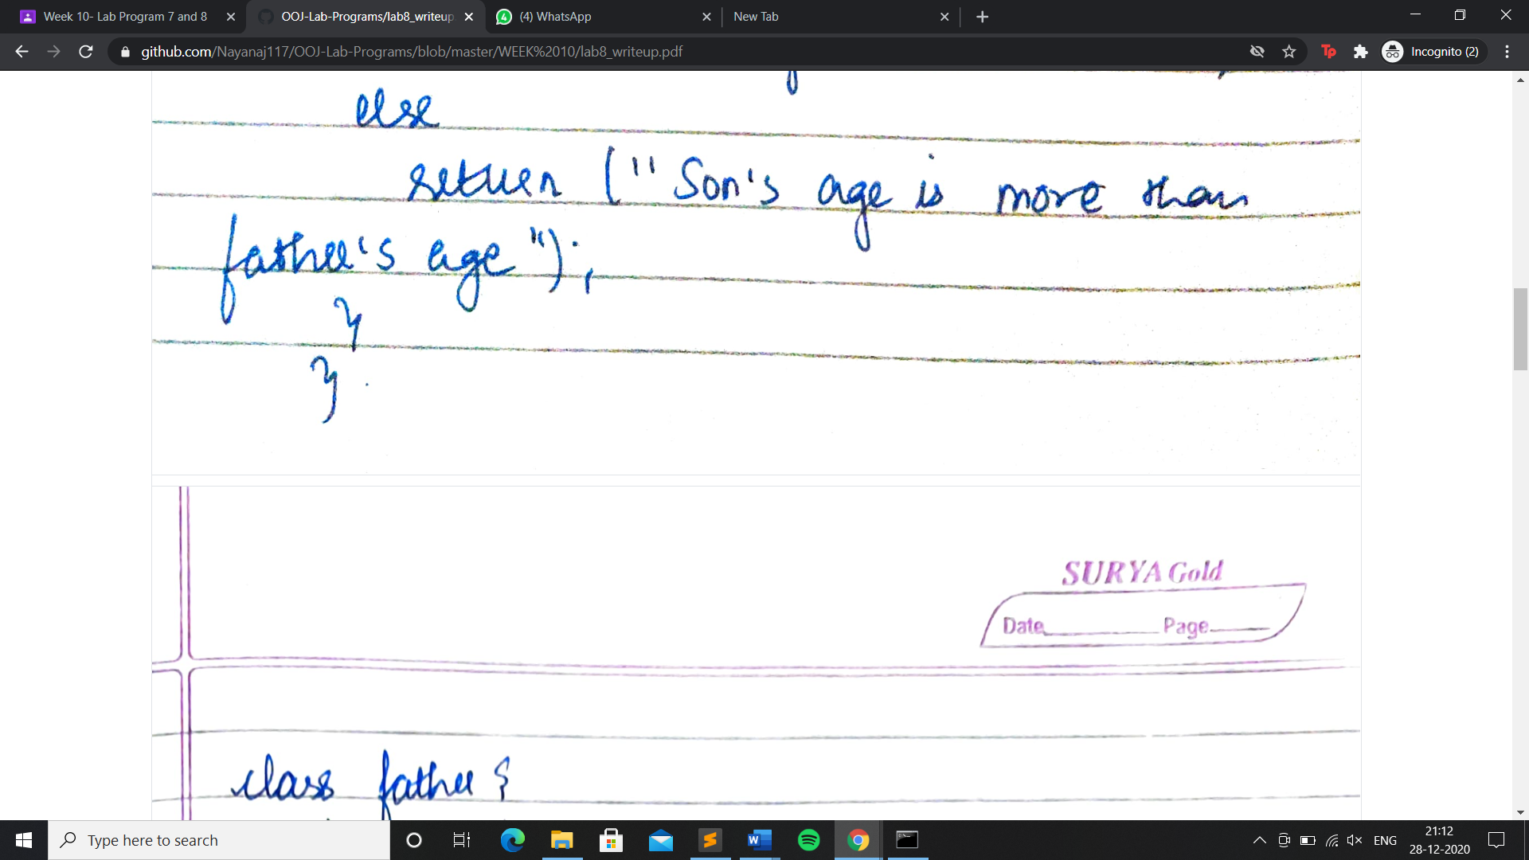

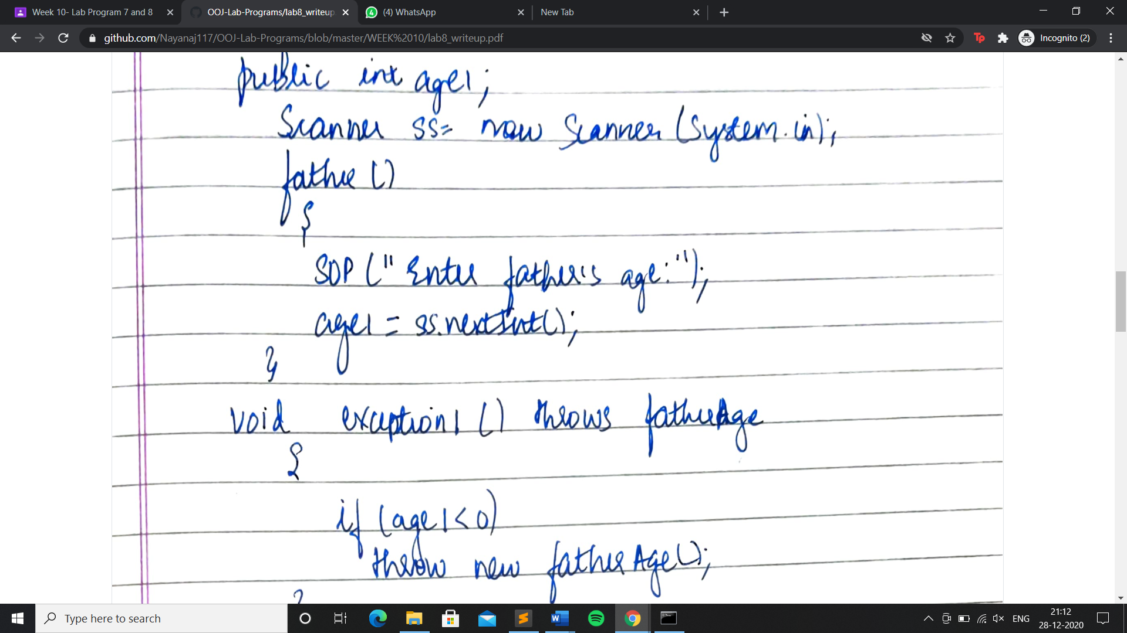

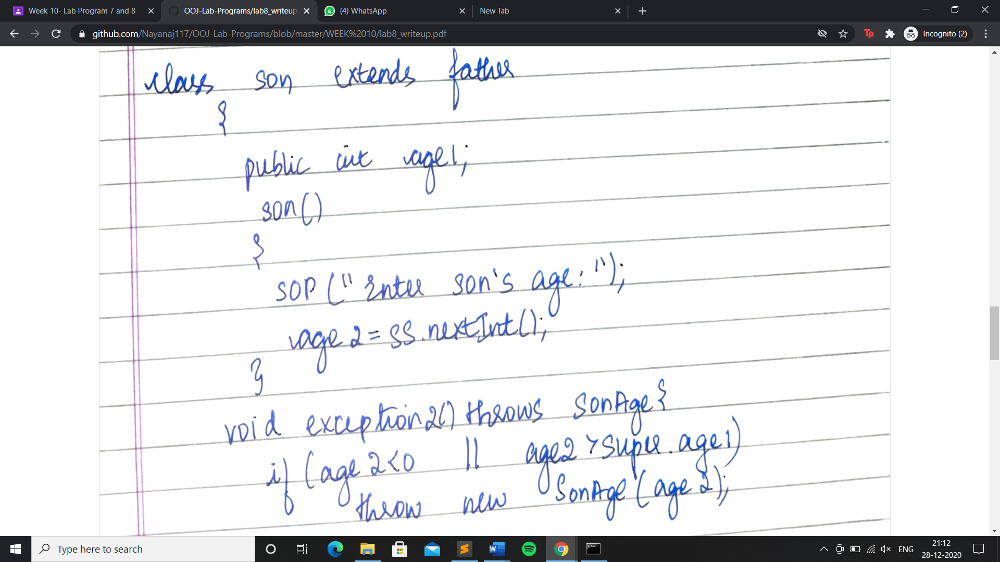

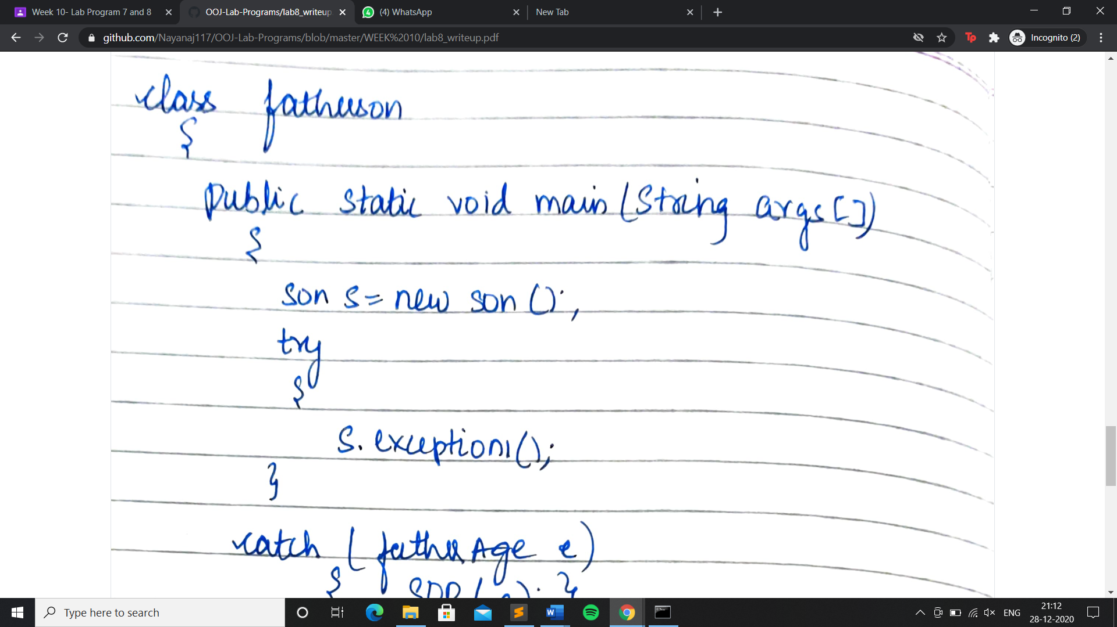

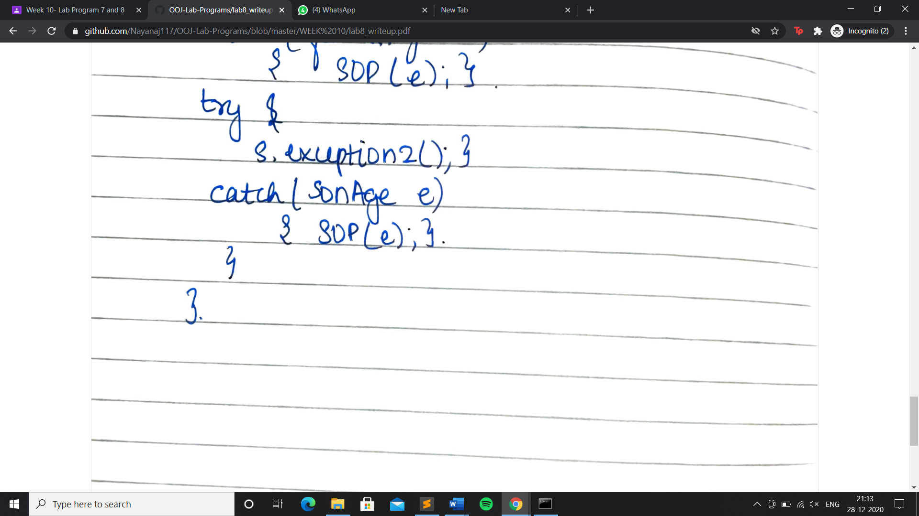

OUTPUT:

